**Cover Page**

**Team Members:** Kenny Paredes, Ivan Lee, Jose Santos

**FINAL UPDATE:**

*Finished items are indicated by “**-Implemented”** next to the title.

Restating Mission statement (Project Goals):

**General -Implemented**

* Implement an application using JDBC
* The GUI specification is to display screens for
  + Movies
  + Cinemas
  + Administrator Control

**Main GUI -Implemented**

* GUI with buttons “Movies” and “Cinemas” and “Administrator”
  + Click “Movies” then a new GUI should display with a list of all currently playing movies
  + Click “Cinemas” then a new GUI should display with a list of all cinemas.
  + Click “Administrator” then a password text box will pop up and after entering the password, admin, a GUI should display to support the administrator functionality

**Comment:** Instead of having a Main GUI that popped up three other GUI, we one main GUI hub that has tabs to display the “Movie” and “Cinemas” and a button to lead to an administrator GUI, with the Movie tab opened by default. More user friendly.

Main GUI Hub/Movie Tab:

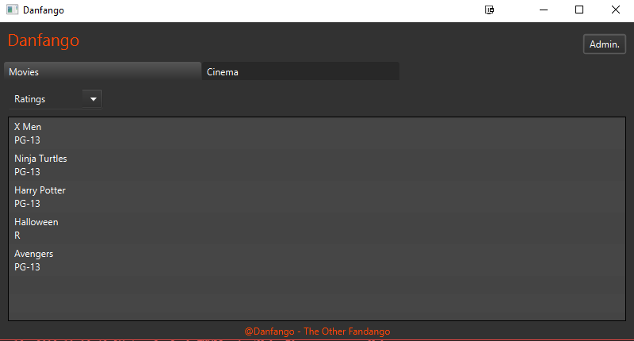

**Movie -Implemented**

* Display a list of currently playing movies
* Rating filter
  + Pulldown menu of ratings
  + Ratings: All, G, PG, PG-13, and R, NC-17
  + Selecting one of the ratings would change the list to only show movies in that ratings
  + All is the default section
* Highlight and double-click a move
  + Display a read-only GUI of all Cinemas where the movie is playing
  + Display the show times of the movie at each cinema where it is playing

**Comment:** When the “Movie” tab is selected all movies are shown in a text list, read-only. Between the tab and the text list is the pulldown menu of the ratings, where All is default and clicking any of them changes the list to that rating. Hovering over a movie highlights it. Double clicking opens a GUI of all Cinemas where the movie is playing.

Double Click for Cinema GUI:

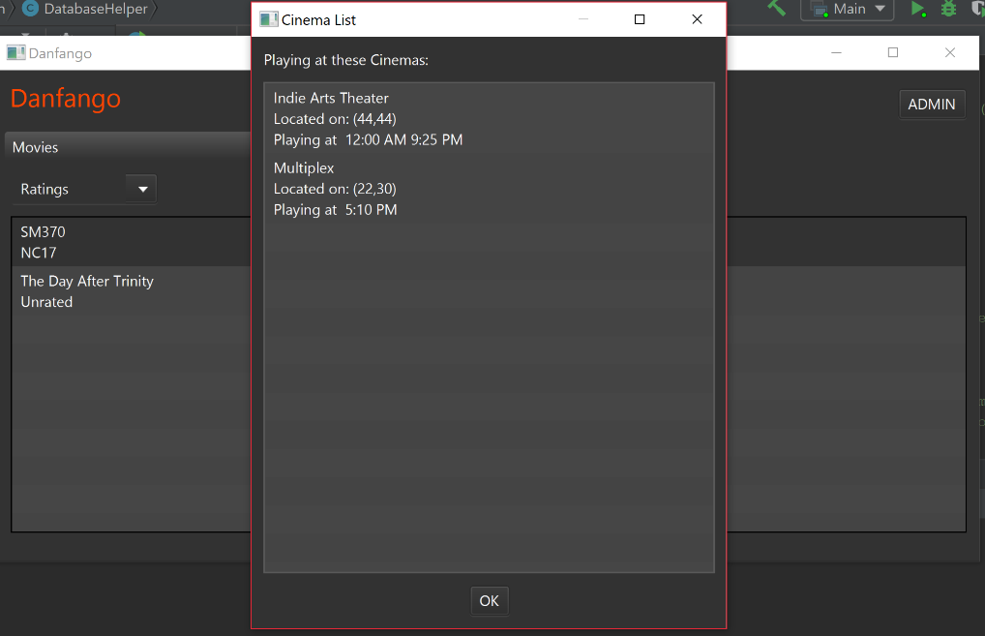

**Cinemas -Implemented**

* Display a list of cinemas.
* Map
  + The client should be able to enter an “address” and a “radius” (in text fields)
  + Display only cinemas where (distance ≤ radius) from the client’s location (address)
  + All cinemas and client addresses are (x, y) coordinates in a square 0 ≤ x, y ≤ 100
  + If either the address or radius field is blank, display all the cinemas
* Highlight and double-click a cinema:
  + Display a read only GUI of all the movies currently playing at that cinema.
  + Also display the show times of every movie currently playing at that cinema

**Comment:** When the “Cinemas” tab is selected all cinemas are shown in a text list, read-only. Between the tab and the text list is the Address boxes for x, y, and within (for radius). When all are filled and “Apply” is pressed the text list will show the cinemas in that radius. Hovering over a cinema highlights it. Double clicking opens a GUI of all movies that cinema is playing.

Cinema Tab And Double Click GUI:

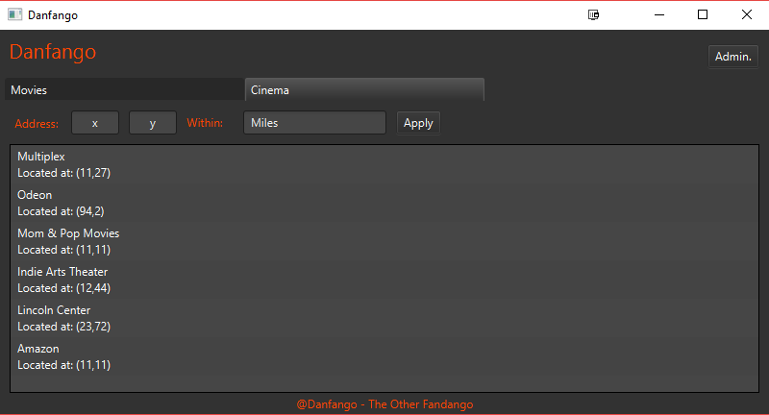

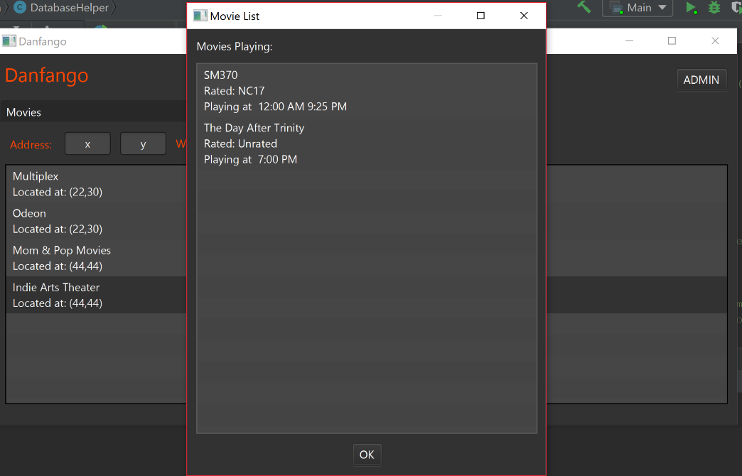

**Administrator -Implemented**

* An “administrator” is authorized to insert/delete rows in the database.
  + The administrator GUI is password protected
  + Only one administrator, so no account name needed.
* Functionality:
  + Insert new movies and delete old ones
    - Movie must have a title and a rating
    - Two movies can’t have the same name
    - Where its being played
  + Insert new cinemas and selects cinemas which are out of business
    - A cinema has a name and an address
    - Two cinemas can’t have the same name
    - List of show times for every movie it plays

**Comment:** Administrator is accessed by a button in the top right corner of the Main GUI hub. You must enter a password and will be brought to a new administrator GUI. The Main GUI can’t be accessed until you press the sign-out button, so there can only be one administrator. The Admin GUI has three tabs: one to edit movies, one to edit cinemas, and another to edit showtimes of movies. Need to put all required information to add to any section. Delete buttons are on the bottom left corner, if there’s a movie/cinema/showtime selected and you press it, it will be deleted.

Add Movies Tab:

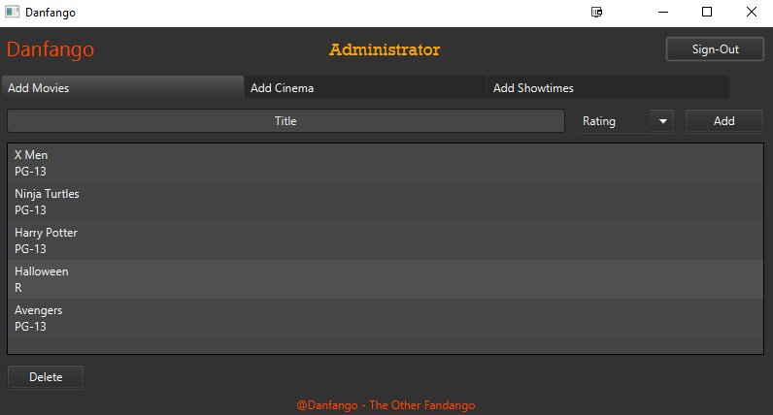

Add Cinema Tab:

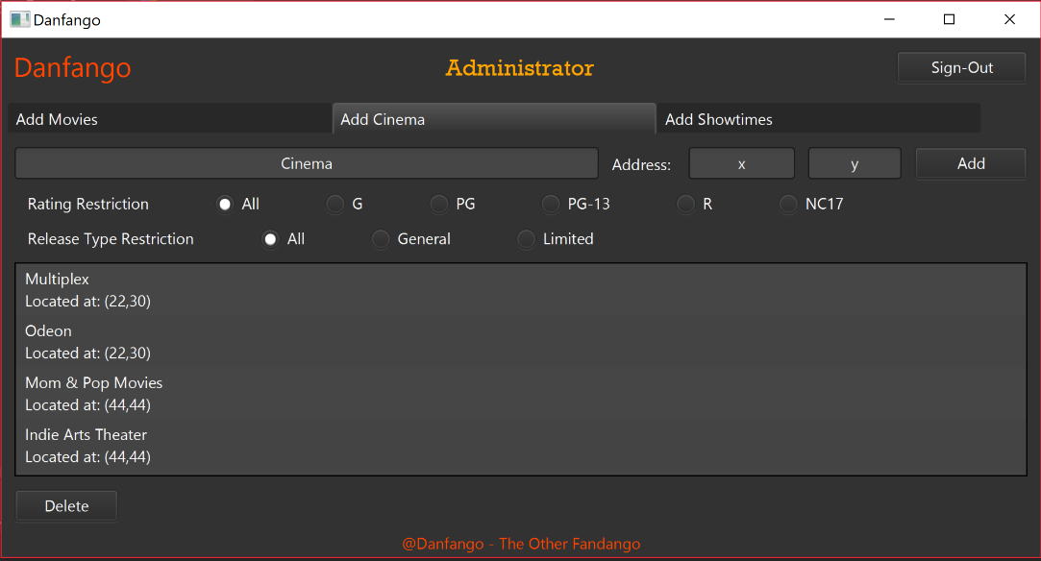

Add Showtime Tab:

